Naresh Nakka (Sr. Performance Engineer)

www.qaprogrammer.com

EROS– API PERFORMANCE TEST PLAN

Contents

**Project Summary** 2

**In-Scope** 2

**Out of Scope** 2

**Entry Criteria** 2

**Exit Criteria** 2

**Server Infrastructure** 2

**Key Scenarios/Key APIs & SLA** 2

**Approach & Test Scenarios** 3

**Performance Testing Tool** 4

**Test Deliverables** 4

**Risks and Assumptions** 4

**Test Schedule** 5

**Approval & Resource List** 5

# **Project Summary**

The purpose of this document is to outline the Performance Test Plan for EROS AKS APIs and their specifications mentioned in Key Scenarios & Workload Model.

## **In-Scope**

* Capacity analysis/summary to find the optimum infrastructure/PODs to support the given throughput for EROS APIs deployed onto Azure Cloud Platform listed in Key Scenarios section

## **Out of Scope**

* Performance Testing for CMS
* Any other APIs and third party integrations
* Tuning the AKS service and infrastructure

# **Entry Criteria**

* Key APIs identified and Approved
* SLA & throughput defined for Each API
* Test environment is fully functioning and stable
* Appropriate access to test environment granted
* Test environment isolated, devoid of any interference, and available to the whole duration of testing activities.
* Dev Ops/Cloud support team to monitor the infrastructure while testing
* Required production like test data made available and validated.
* Production like or Scaled down environment for Performance testing.

# **Exit Criteria**

* Throughput and response times have met documented SLAs(if applicable)
* When SLAs are not met providing conditional sign-off.

# **Server Infrastructure**

Application Server Infrastructure:

Standard_s16s_v2 (VCPU16 and Memory 32GB)

Load testing VM Capacity Requirement details:

Based on standard benchmarking*

|  |  |  |  |
| --- | --- | --- | --- |
| Number of VMs Required (Ubuntu Servers) | CPUs | Memory | Supported TPS/One API |
| 1 VMs | 2VCPUs | 16GB | 5K TPS |
| 2 VMs | 4 CPUS | 16GB | 10K TPS |
| 20 VMs | 4CPUs | 16GB | 100K TPS |

# 

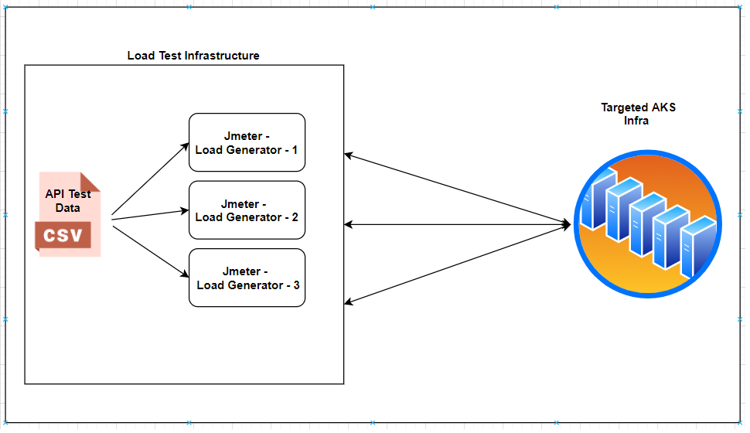

# **Key Scenarios/Key APIs & SLA**

**SLA: Service Level Agreement:**

Avg. processing Time on Server Side for Each API should be <=30 milliseconds

Cycle 1:

A baseline test will be conducted on below APIs to identify the required infrastructure capacity.

|  |  |  |
| --- | --- | --- |
| API | **SLA**  **(m.s.)** | **Required TPS** |
| **Card List/Card Details** | 30 | 10000 |
| **Search(Asset)** | 30 | 10000 |

Cycle 2:

|  |  |  |
| --- | --- | --- |
| API | **SLA**  **(m.s.)** | **Required TPS** |
| Page Map | 30 | 10000 |
| **Navigation** | 30 | 10000 |
| **Card List/Card Details** | 30 | 10000 |
| Heart Beat | 30 | 10000 |
| Image type | 30 | 10000 |
| Onboarding | 30 | 10000 |
| STARAPIs | 30 | 10000 |
| Add Rating | 30 | 10000 |
| Asset/Content with Sub-asset | 30 | 10000 |
| Content Play API | 30 | 10000 |
| Continue Watching | 30 | 10000 |
| **Search** | 30 | 10000 |
| Watch list | 30 | 10000 |
| Watch History | 30 | 10000 |
| Playlist | 30 | 10000 |
| Groups/Channels | 30 | 10000 |

Cycle 3:

|  |  |  |
| --- | --- | --- |
| API | **SLA**  **(m.s.)** | **Required TPS** |
| **Page Map** | 30 | 200000 |
| **Navigation** | 30 | 200000 |
| **Card List/Card Details** | 30 | 200000 |
| **Heart Beat** | 30 | 200000 |
| **Image type** | 30 | 200000 |
| **On Boarding** | 30 | 200000 |
| **STARAPIs** | 30 | 200000 |
| **Add Rating** | 30 | 200000 |
| **Asset/Content with Sub-asset** | 30 | 200000 |
| **Content Play API** | 30 | 200000 |
| **Continue Watching** | 30 | 200000 |
| **Search** | 30 | 200000 |
| **Watch list** | 30 | 200000 |
| **Watch History** | 30 | 200000 |
| **Playlist** | 30 | 200000 |
| **Groups/Channels** | 30 | 200000 |

**Note:** Cycle 2 would be considered based on client requirements, subjected to change (required TPS).

# **Approach & Test Scenarios**

* Each API to be tested individually to achieve the following
  + Achieve the given TPS
  + Adhering the SLAs
  + Identify the optimal size of pod(s)/clusters configuration.

# **Performance Testing Tool**

* Apache Jmeter will be used to conduct all performance testing activities where each API will be considered as an individual test script
* Test tool will be configured as either Standalone or distributed in nature to support the given throughput requirements.
* Test Infrastructures / Servers / VM to be provided by infrastructure team to meet the throughput requirement on-demand basis, with in the application farm to minimize the network latency.

# **Test Deliverables**

* At the end of each test, detailed test report will be provided which includes
  + **From Performance Testing Team - Client Side Metrics:**
    - Test Window
    - API tested
    - API Performance Table – Avg., 90 Percentile, 95 Percentile, Max, Min Response times
    - Server Side Avg. Processing time(From Kibana) – Avg., 90 Percentile, 95 Percentile, Max, Min Response times
    - Client Side - error/failures information
  + **To be delivered by Devops/Infrastructure team - Server Side Metrics:**
    - Server CPU & Memory Consumption
    - PODs used & Configuration details.
    - Network Usage
    - DB Usage & Performance details
    - Server Side Errors, Infrastructure Errors and bottlenecks

# **Risks and Assumptions**

* Application is functionally stable
* Middle tier components such as gateways, firewall and load balancers are optimized to support the given load requirements.
* Server Side processing times well logged which includes
  + Processing times for each API
  + Failure & Error information
  + API information
* Jmeter VMs in the same subnet/ same infrastructure where application is being hosted

# **Test Schedule**

|  |  |
| --- | --- |
| Cycle | Test Window |
| Cycle 1 – Baseline | 15/09/2020 – 18/09/2020 |
| Cycle 2 – All APIs | 21/09/2020 – 25/09/2020 |
| Cycle 3 – All APIs | 28/09/2020 – 02/10/2020 |

# **Approval & Resource List**

|  |  |  |
| --- | --- | --- |
| Approved by | Roles & Responsibilities | Status |
| Naresh N | Performance Engineer (Powerup Cloud) | Author |
| Venkat Kotapati | QA Manager (Powerup Cloud) | Approved |
| Arun Thomas | Dev. Lead(Powerup Cloud) |  |
| Gavaskar | Azure Practice Head (Powerup Cloud) |  |
| Vinod Kumar | Project Manager(Powerup Cloud) |  |
| Single Signoff Authority (Eros) |  |  |
| Microsoft Azure Team Signoff Authority (SPOC) |  |  |
|  |  |  |